Angular BY MAXIMILIAN
Main.ts
How does our aplication egt to know how it has to refer app component only?  It is th eindex.html that refers to it. | 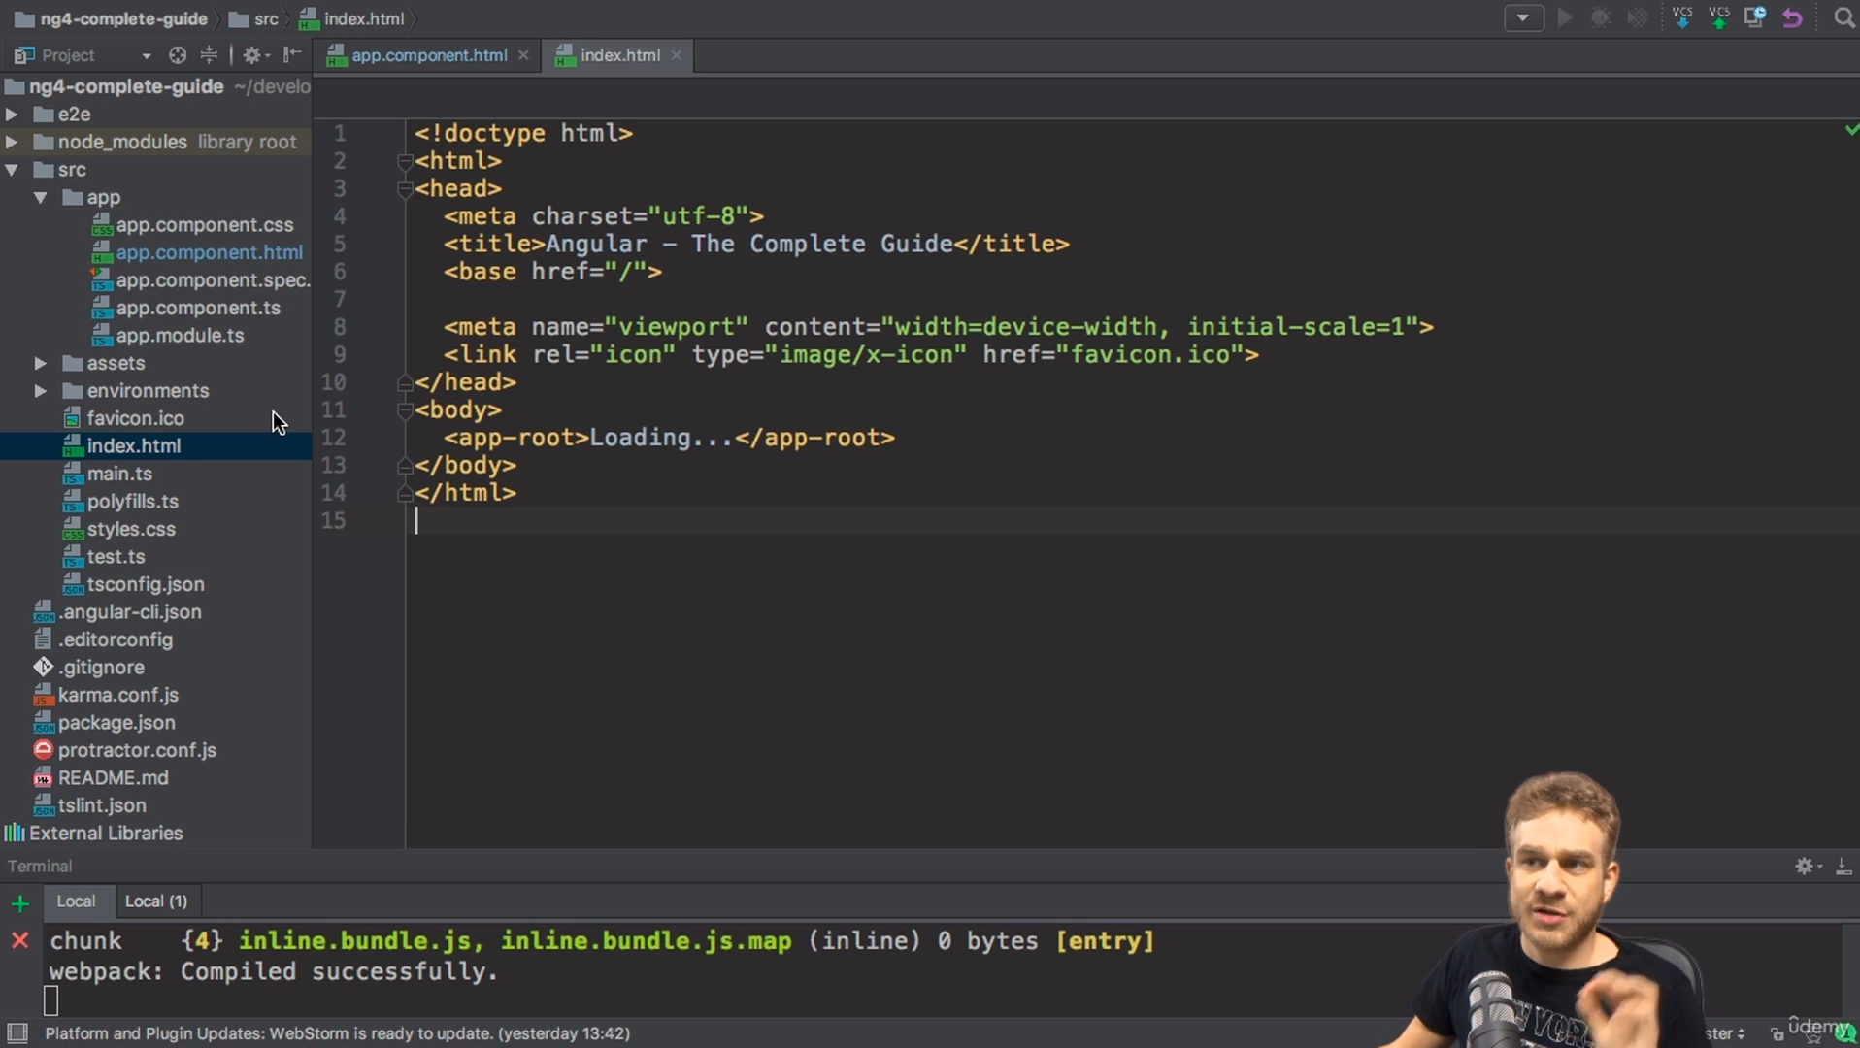
The very first point of starting th application is the main.ts file which will bootstrap the app module | 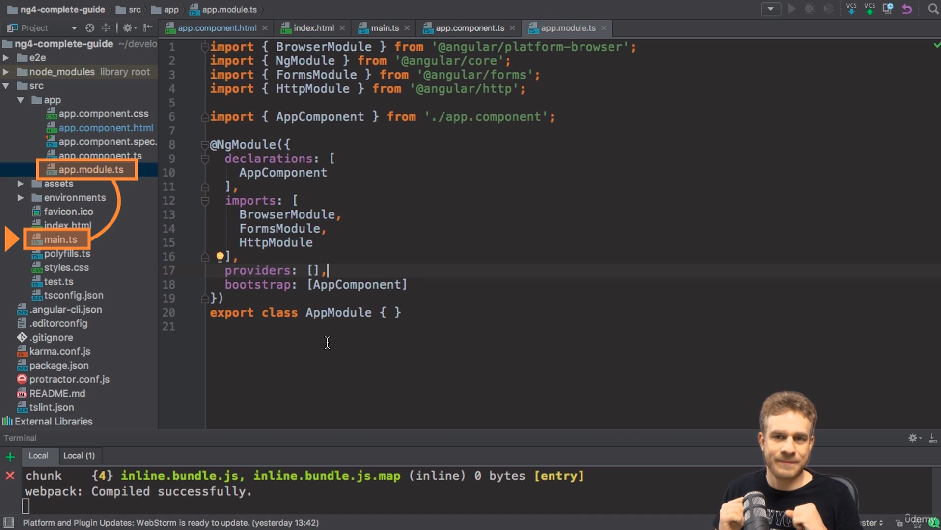
Flow of the app.firts-->main.ts will bootstrap appModule which in turn will bootstrap-->appComponent and then app compoenent will be rendered by index.html | App-module.ts  App-compoennet.ts  Index.html uses(approot)
What ever component we make we need to register it with the app.module.ts .  @NgModule will tell angular that there is a component named server compoennt which u shoudl find out and use. | 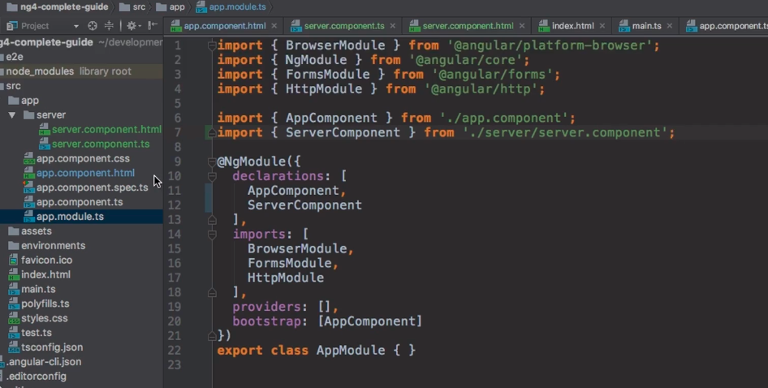
Ng g c new-component will generate a component
We can add inline html and an inline css to our .ts file as shown aside | 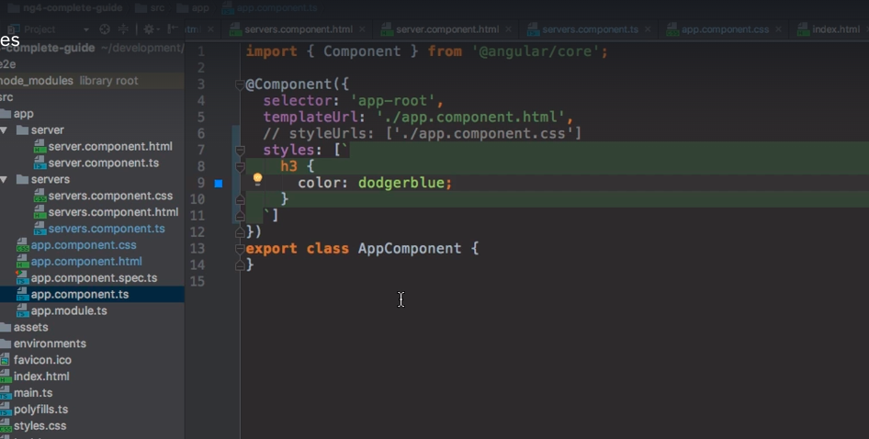
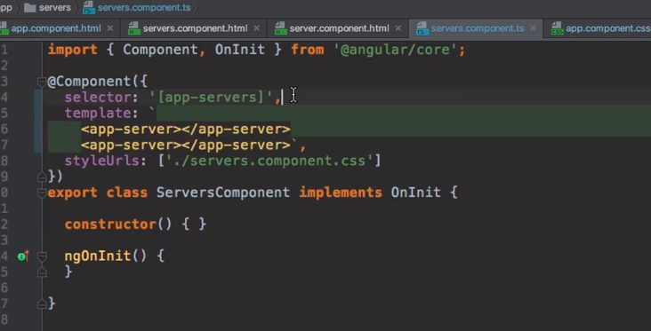
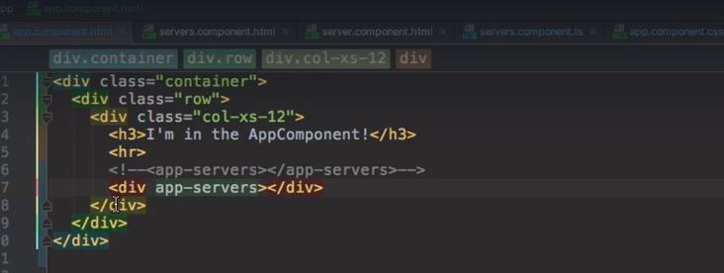
If we want to use our component as an attribute then we can:
1.we need to specify as a div property(or html element property)
2.declare it as an attribute in its ts file
We can also specify as a class | 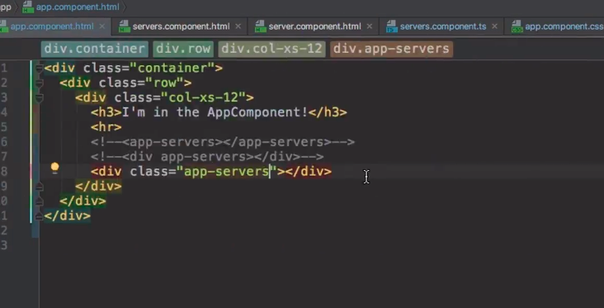
String interpolation | 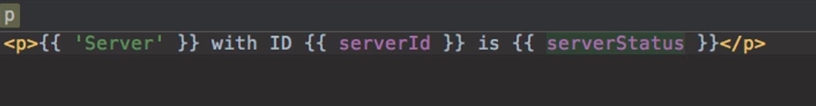  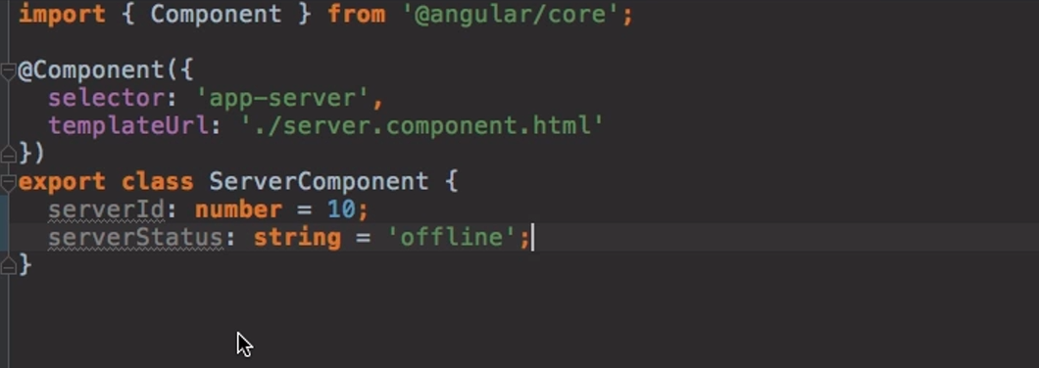
Making a method to retrun a server status and calling it from the html  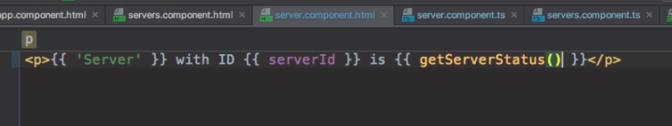 | 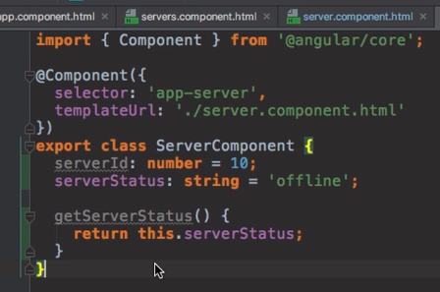
Property Binding  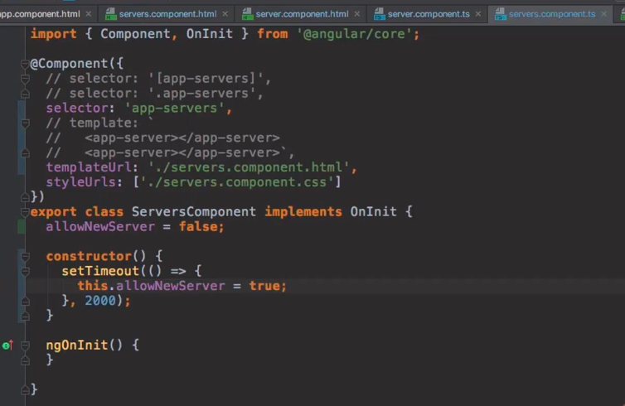 | 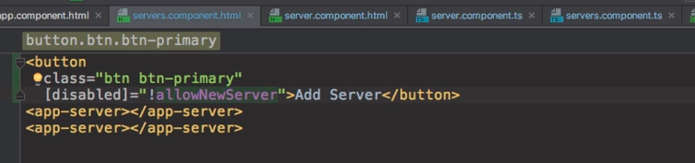
Event Binding

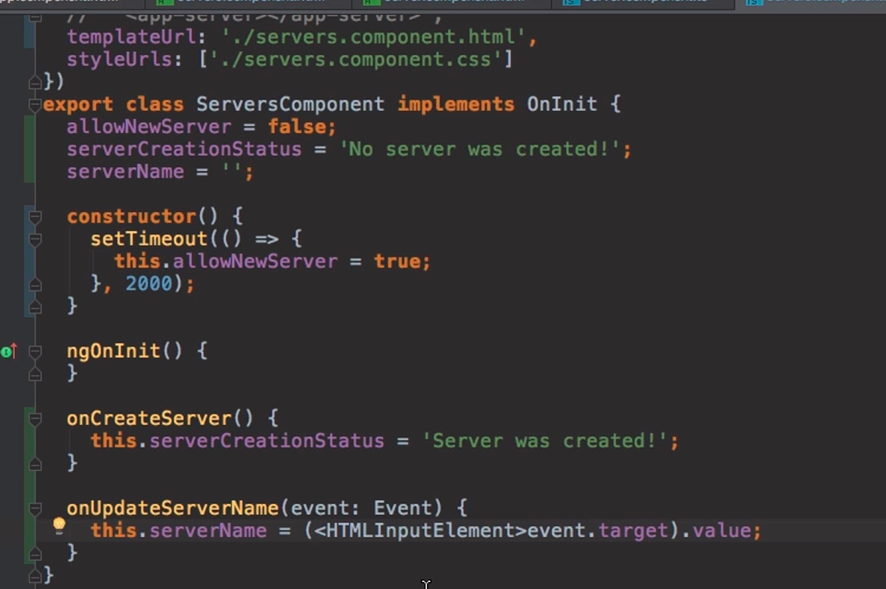  Input gives us some data and can be passed to amethod using $ | 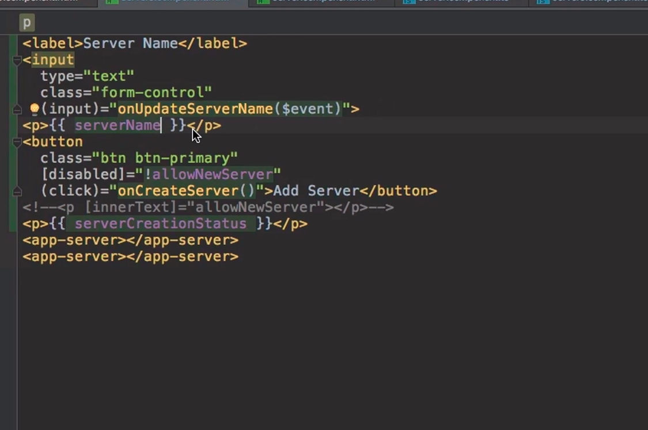

NgIf directive
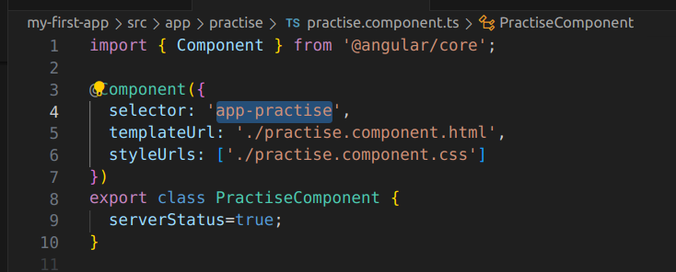 | 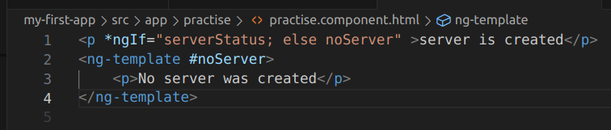

NgStyle
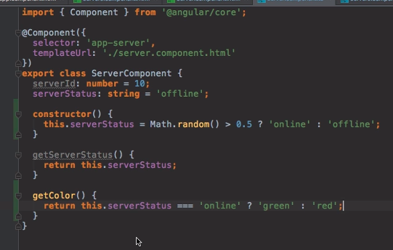 | 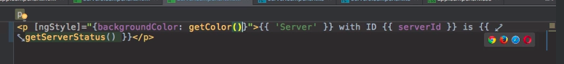
NgClass vs ngStyle
Here's a quick comparison:
- ngClass is used when you want to add or remove entire CSS classes dynamically.
- ngStyle is used when you want to set individual CSS properties dynamically
Project

app-component
DATA BINDING
app-header
App-recipe

Shopping list
recipe-list
app-header
Recipe detail
recipe-detail
Shopping edit

suppose we want to send some property from the parent element to the child element then you can do as below
App.component.ts  we have a serverElements array here. | 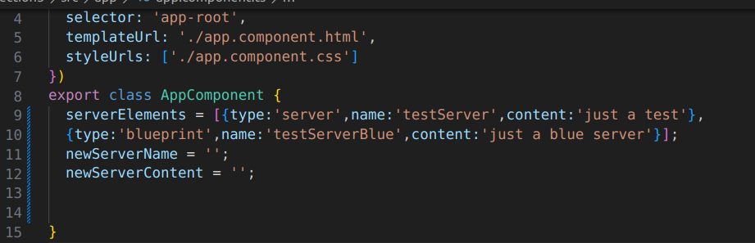
Now in html we will pass it.the serverElement coming in the llop will be passed to the ‘element’ property o fthe server-element. | 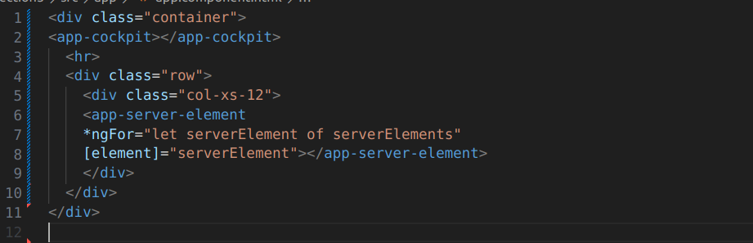
We will take is as an input in the server element in ts file. | 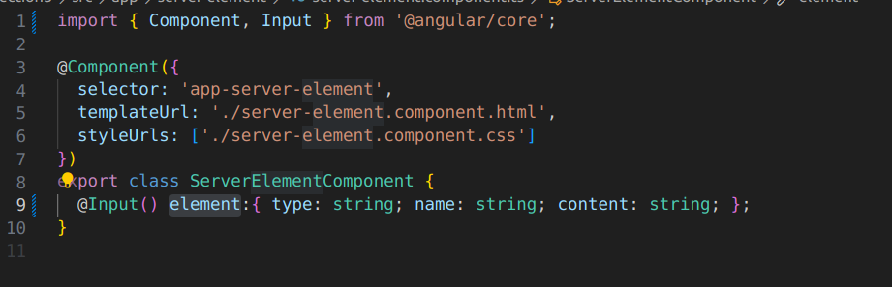
The value can be fetched here in the html file | 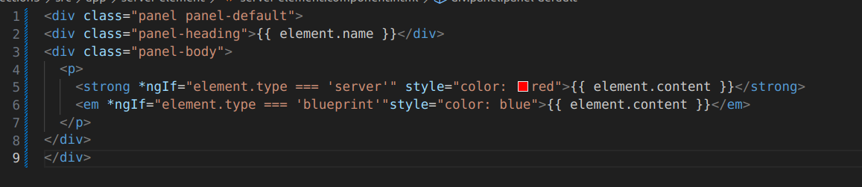
Alternatively,if we want some other name to be passed.we can pass it as ‘srvElement’ | 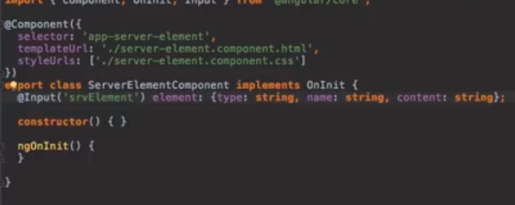

PASSING VALUES FROM THE CHILD TO THE PARENT ELEMENT
We have app-component.html file.  Here {serverCreated} is the value passed by the child component.when value is passed from child the onServerAdded method will be called with the data passed by the child($event) | 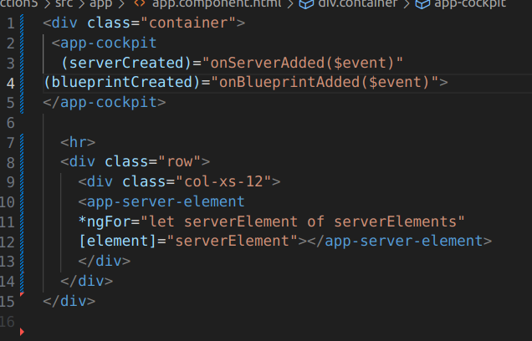
App.componenet.ts file | 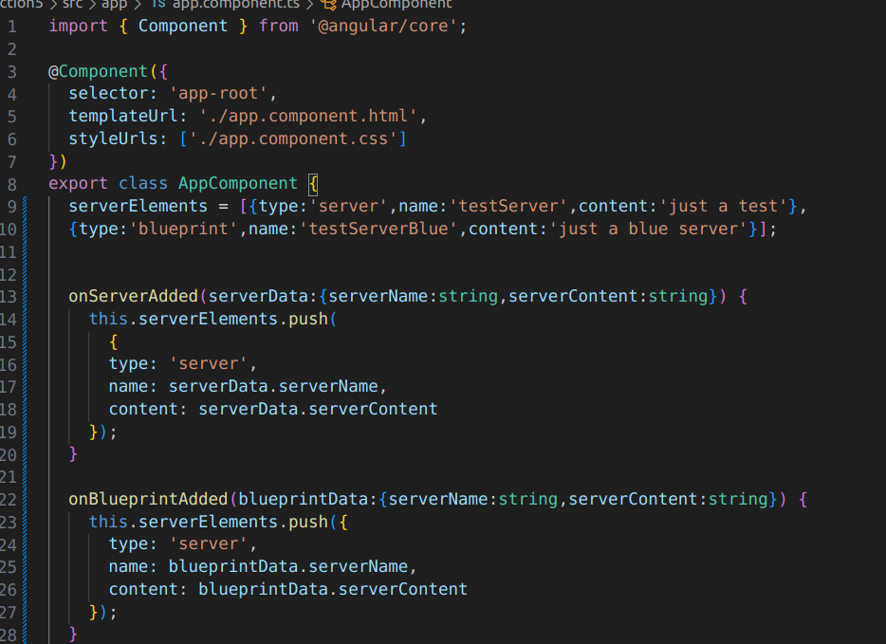
Child component:  when the button will be clicked then onAddServer() will be called which will emit an event | 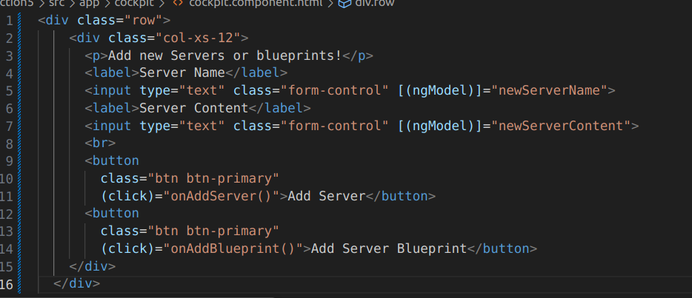
Theemitted event will send the dat ato the parent componenet | 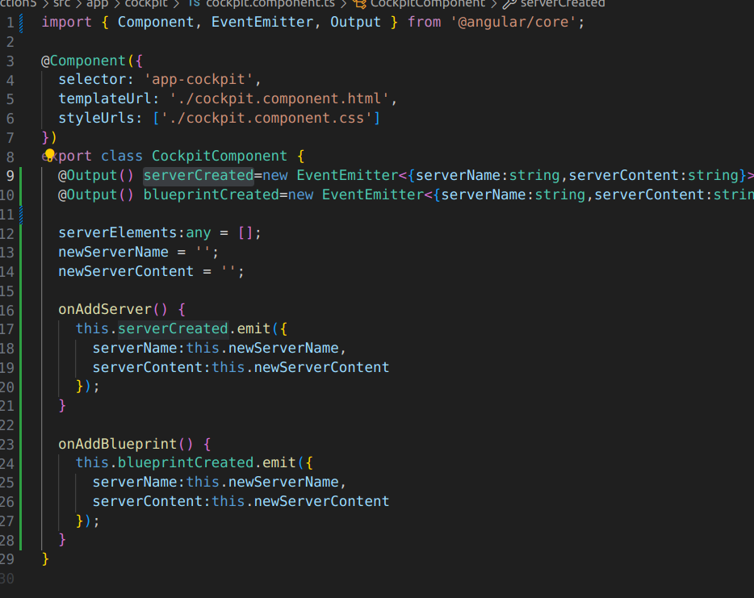
ng-content
POINTS TO REMEMBER

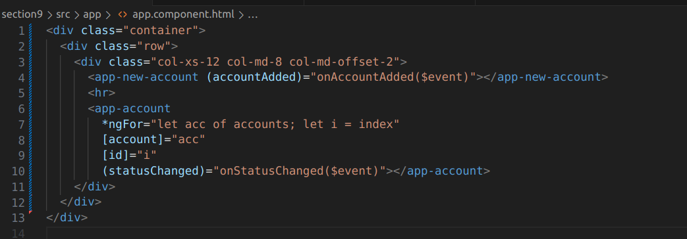
IN the above piccture we have a app.componenet.html which is the starting point .It has a ts file in whihc the values are defined.So the values going from aa-ts to the child are denoted by-->[]
and the values coming from child to parent are denoted by ().

Ng content
sometimes we want to pass some vaues from the parent to the child compoent so we will use the ng content
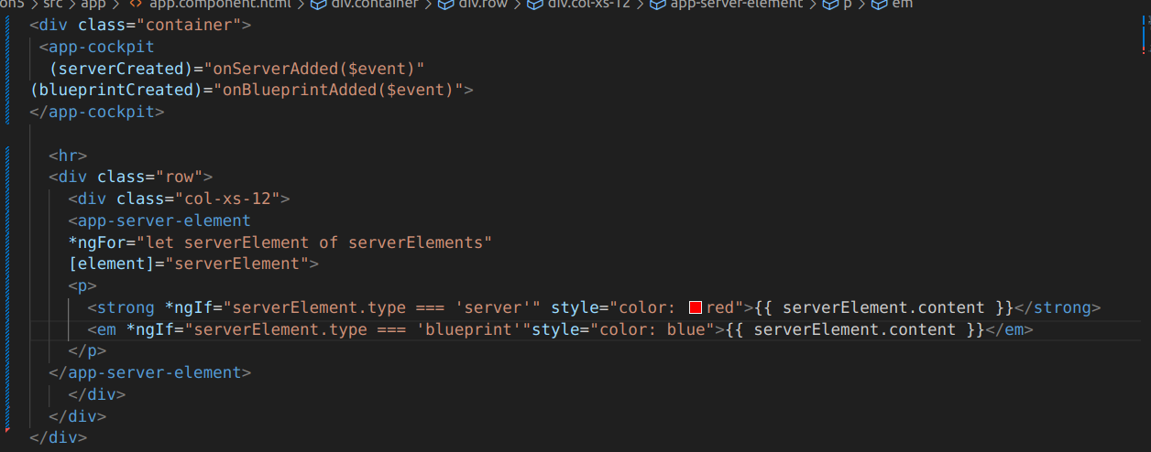 | 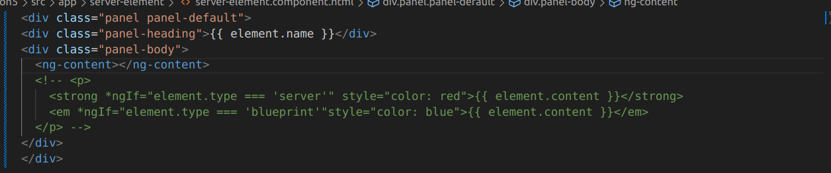  Here p has been replaced with ng content

NgContent
ng content is simple used use a contetn menitioned for the child in the parent directly in the child so we will type <ngcontent> whihcih will take the items from the parent as it is.
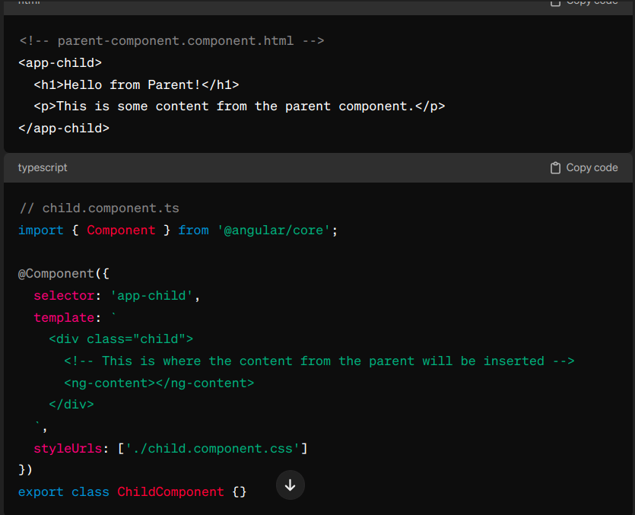

@ViewChild
Imagine you have a parent component and a child component in an Angular application. The parent wants to interact with something specific in the child, like a method or a DOM element.

Here's how you'd do it using @ViewChild:
typescriptCopy code
import { Component, ViewChild, ElementRef } from '@angular/core';

@Component({
selector: 'parent-component',
template: `
<child-component></child-component>
`
})
export class ParentComponent {
// With @ViewChild, we can grab a reference to the child component
@ViewChild(ChildComponent) childComponent: ChildComponent;

ngAfterViewInit() {
// Once the child component is initialized, we can access its methods or properties
this.childComponent.sayHello();
}
}

@Component({
selector: 'child-component',
template: `
<div #childDiv>Hello from Child</div>
`
})
export class ChildComponent {
// Here, we use @ViewChild to grab a reference to a specific DOM element
@ViewChild('childDiv') childDiv: ElementRef;

sayHello() {
// When called, this method logs the text content of the childDiv element
console.log(this.childDiv.nativeElement.textContent); // Logs: "Hello from Child"
}
}

In this example:
- The parent component (ParentComponent) contains the child component (ChildComponent) in its template.
- Using @ViewChild(ChildComponent) childComponent: ChildComponent;, the parent component grabs a reference to the child component. Now, it can access properties and methods of the child.
- In the child component (ChildComponent), we define a div with the text "Hello from Child" and assign it a template reference variable #childDiv.
- @ViewChild('childDiv') childDiv: ElementRef; allows the child component to get a reference to this specific DOM element.
- Finally, in ngAfterViewInit() of the parent component, it calls a method (sayHello()) on the child component, which logs the text content of the childDiv element.

LIFECYCLE
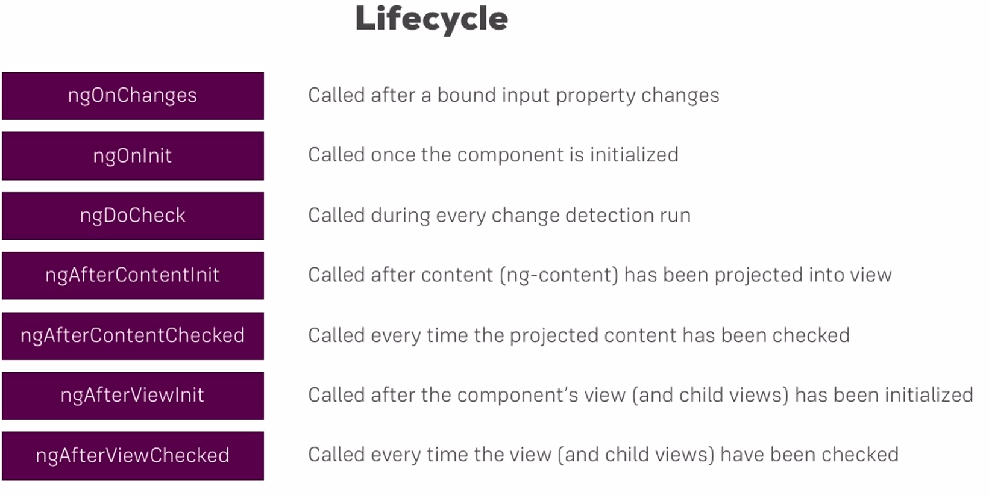
Section 7
Applying directives

we have a ts file an da cass and html file on which we want to apply some properties
This | 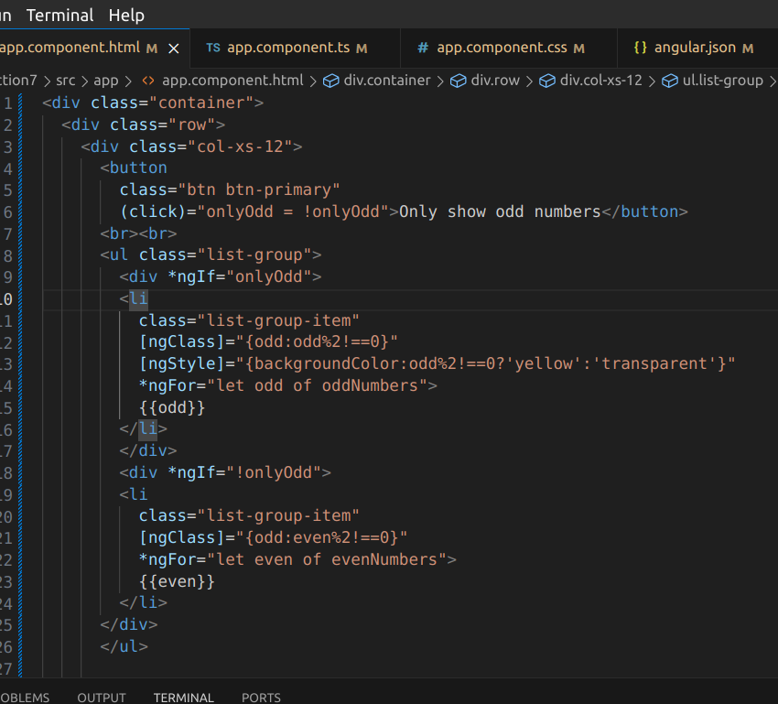
Css file | 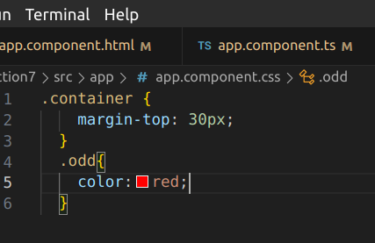
Ts file which has the odd umbers | 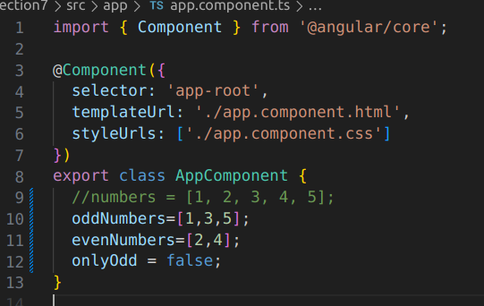

CREATING DIRECTIVES

we can make our own directives as shown below:
Under the app folder make a folder named app-highlight.and make a file under it “basic-highlight-directive.ts” | 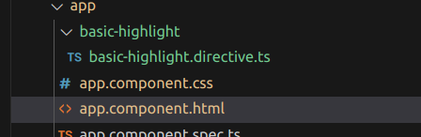
In the directive file we will write as below | 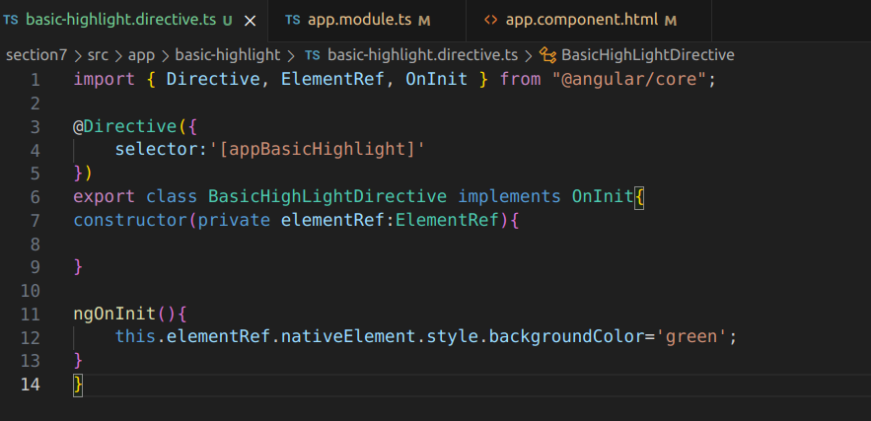
 | 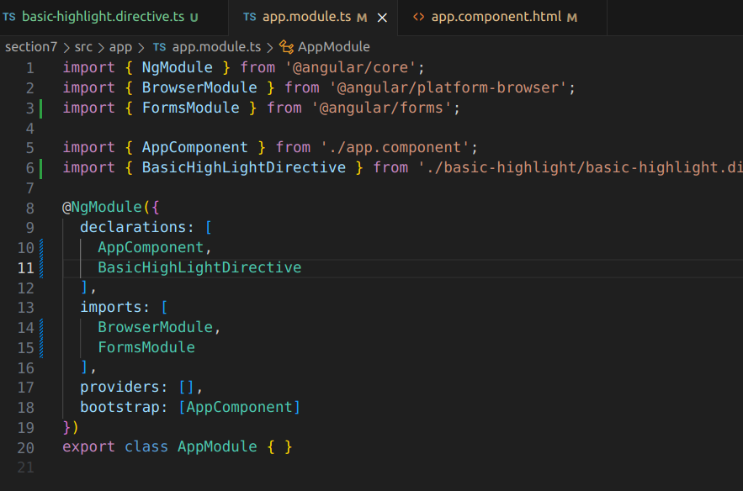
We will import the directiev in the app.module.ts file

Using rendere to create a directive
We will make a directive using a ng g d basichightlight
Ts file | 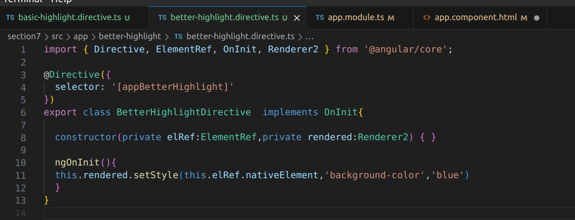
Module import in module.ts file | 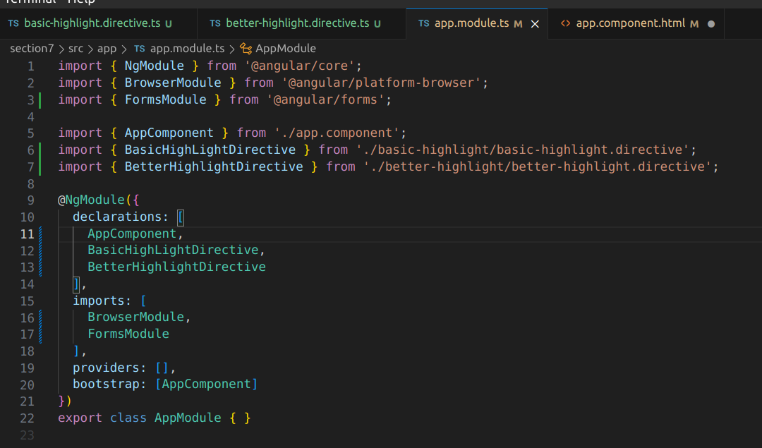
Using i tin app.component.htl | 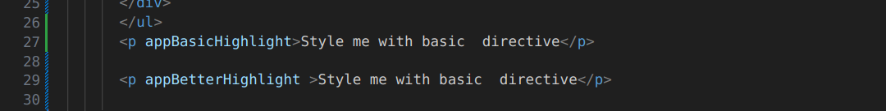
HostLisener to listen to events

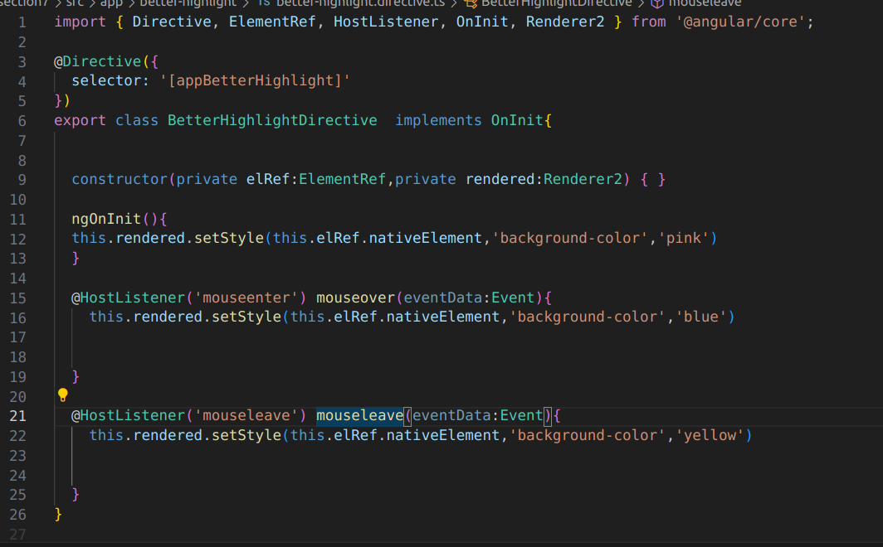
HostBinding
there is another way of doing the hostBinding
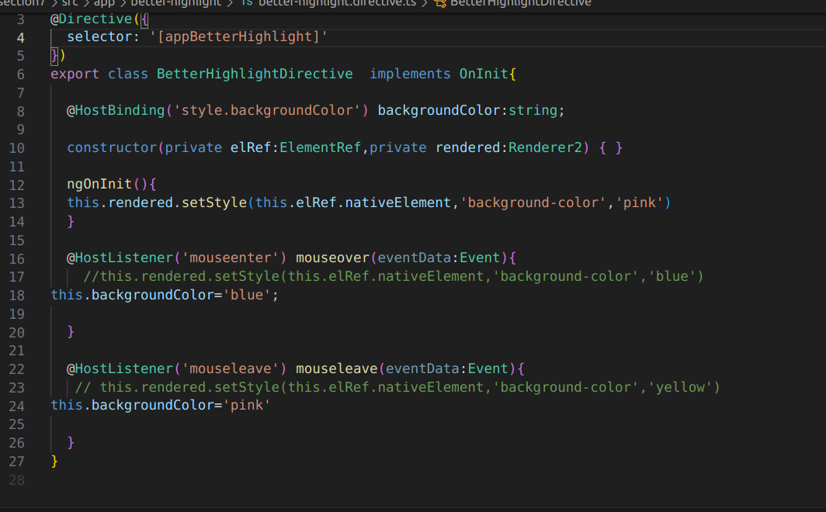
SERVICES
what are services
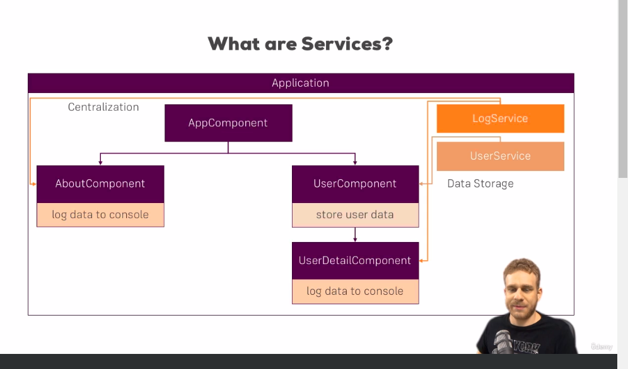
services help us to use the same functionality from different places.

USE OF SERVICES
Suppose we are in a need to add logging to our application so what do we do it that we write it just plain anywhere but now we need to add it in a service class. | 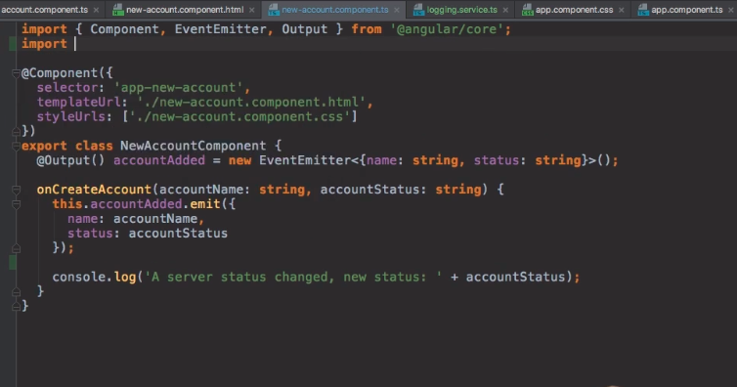
We make a logging service class | 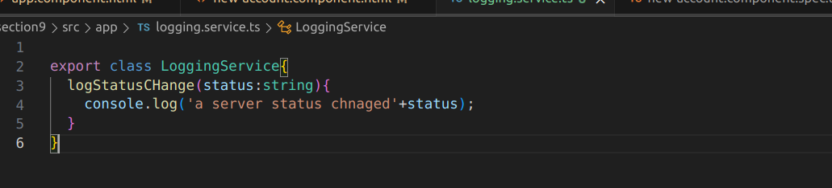
Then in the ts file where we want to use it we will inject it int the constructor for dependency injection | 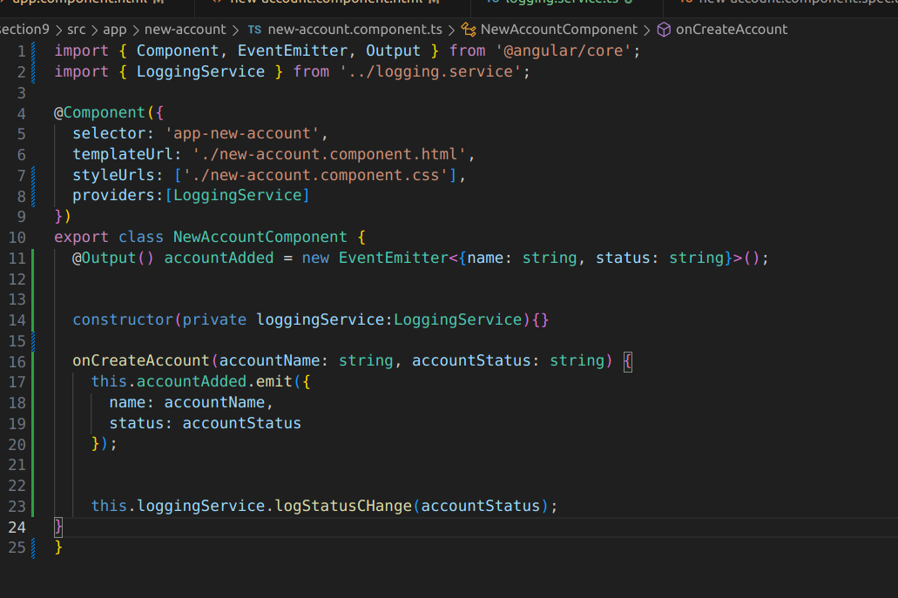
We can inject in as many classes or components we want so that we can use i.

@Injectible
suppose we have a service whihc needs to injected into a service so the service into which other service is to be added is marked with injectable.
Looging nees to be aded into addServcie

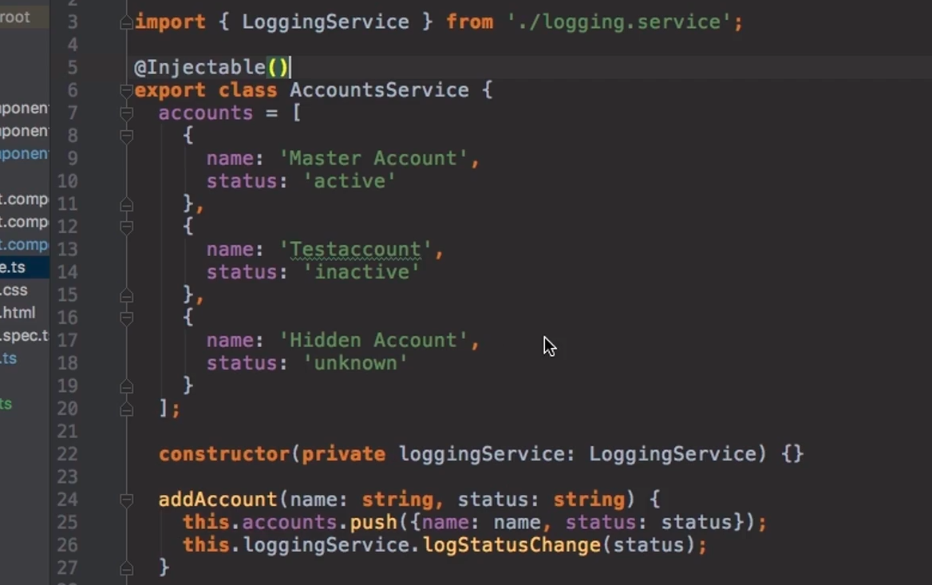
Inter component communication using services
We have account service which has ‘statusUpdated’ variable. | 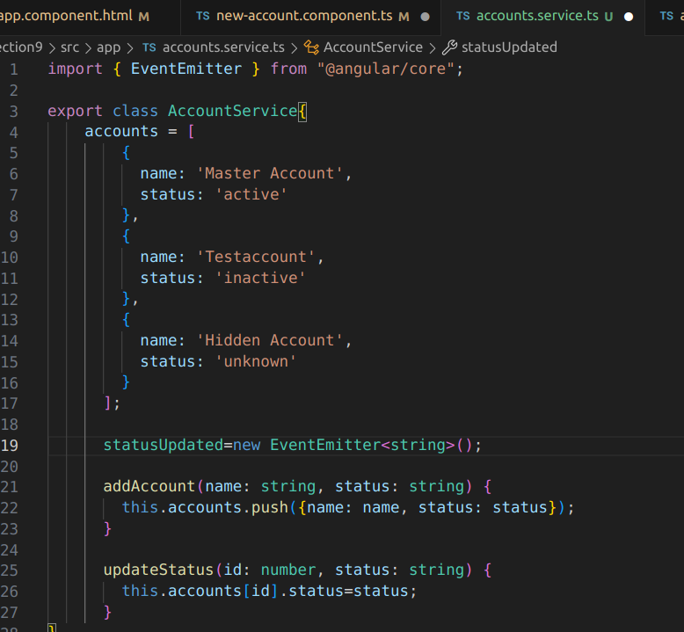
Account component wants to send some data to the newAccount component.so will be sent by the account component(line 18) | 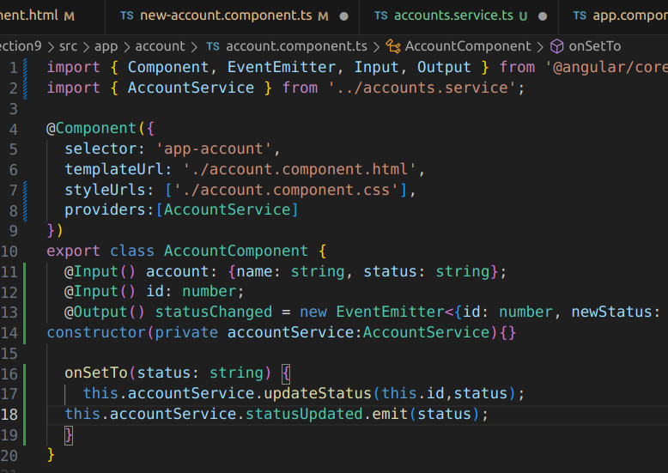
New-account -component will subscribe to get the data | 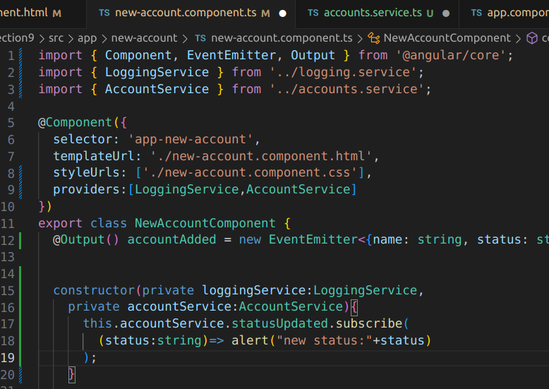

Section 11
ROUTING
in order to add routes you need to add the below code
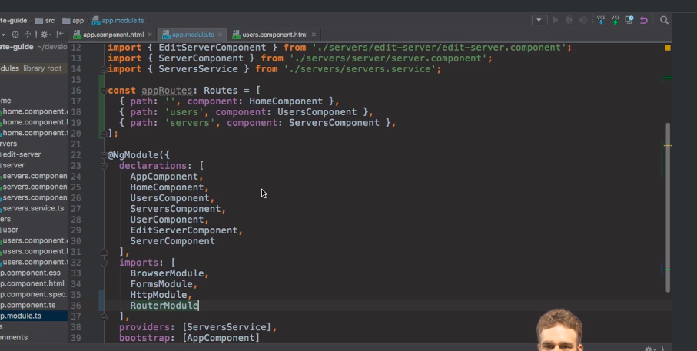
line 36 is for declaring our app to use routing.
An alternative way to define routes is through a app-routing-module.ts file.Then this file can be added to app.module.ts file
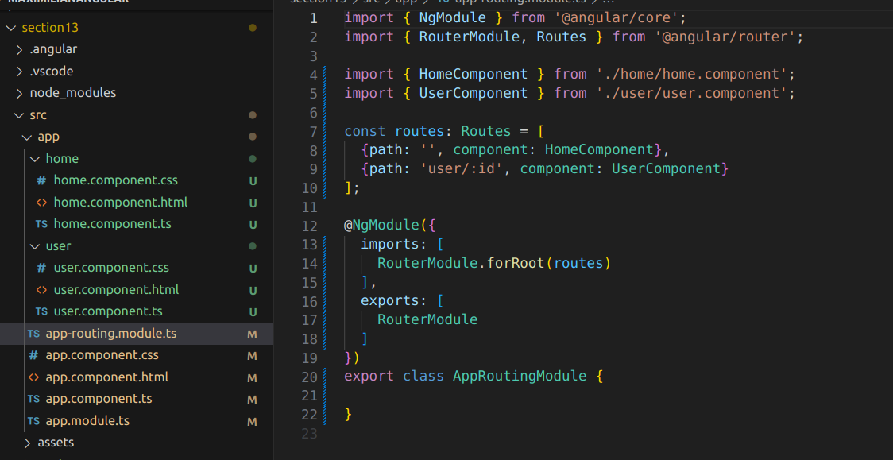

Imports here will specify to use the declared approutes for our root compoent | 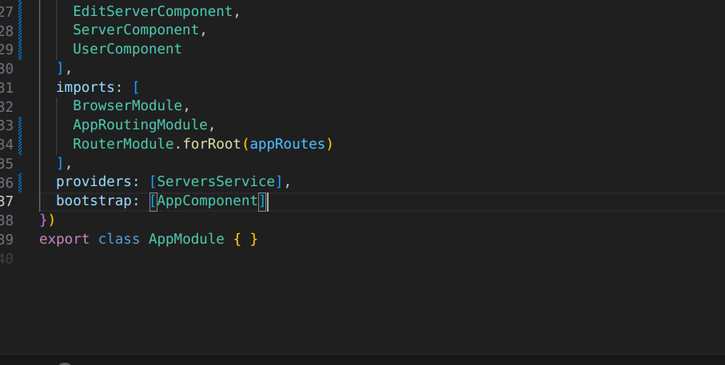
We will delete the rows from the file so that our appliction knows where to render the router | 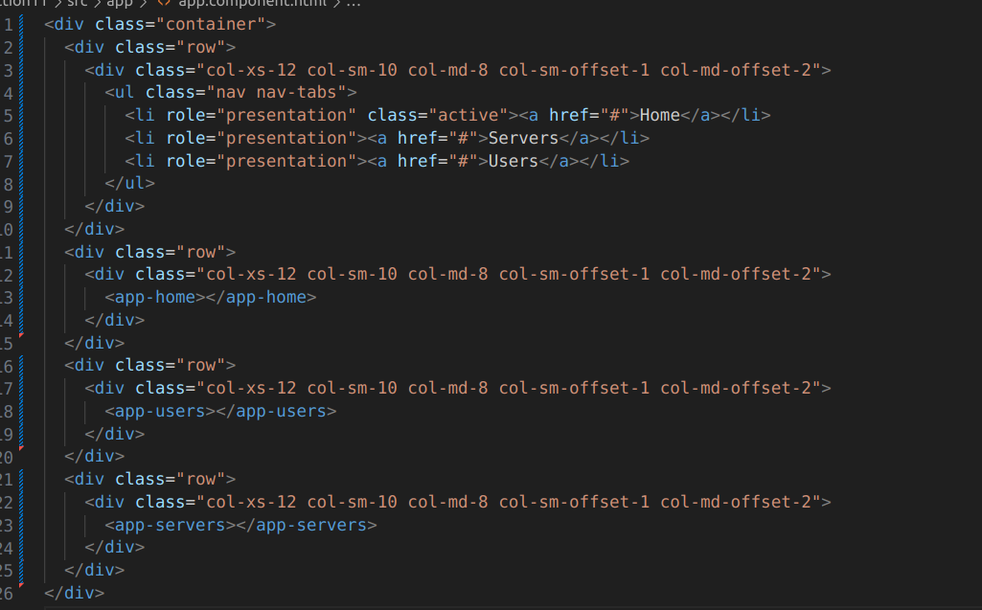
We will add router outliet here | 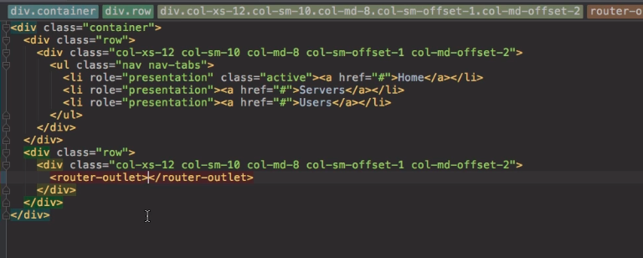
How we define route.It will not reload the app. | 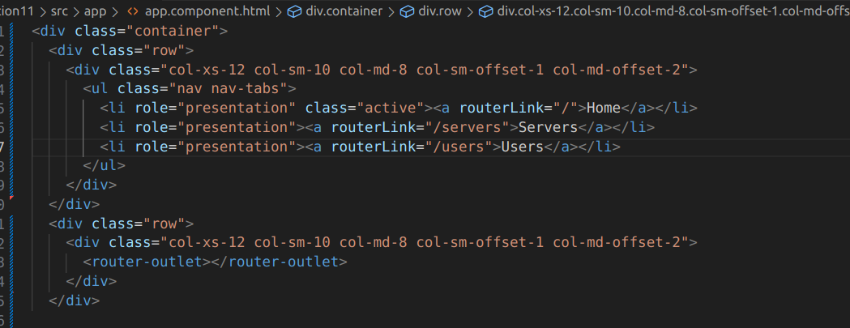
How can we navigate inside the components  when we have to navigate inside a component then we do not give/servers because then it will search for relative path | 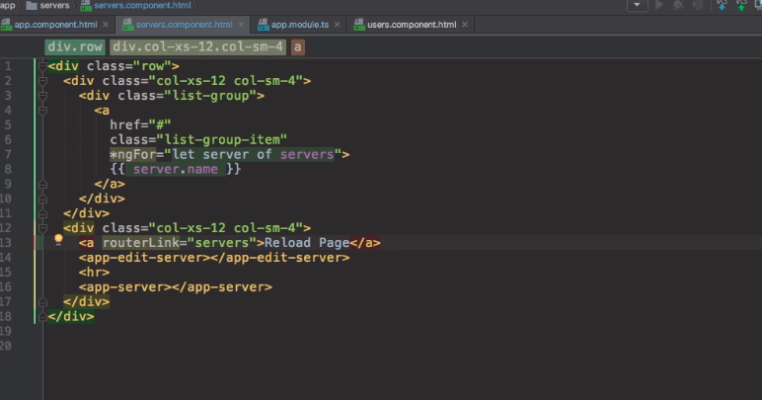
Here we have three routes[\,\servers,\users] but when we switch between them the home tag always remains selected because the path \ is common in all so we need to specify a special property on the / [routerLinkActiveOptions]="{exact:true}">  to mark it to be selected only if exact path is only \. | 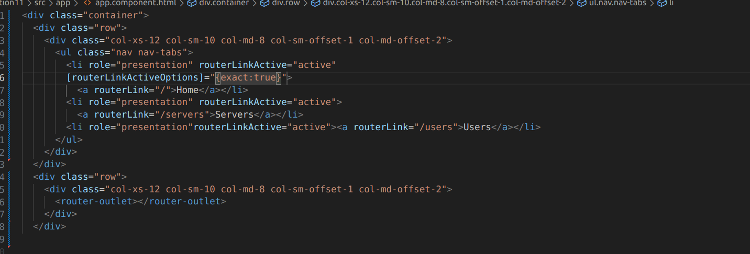
This si how the aboevlooks | 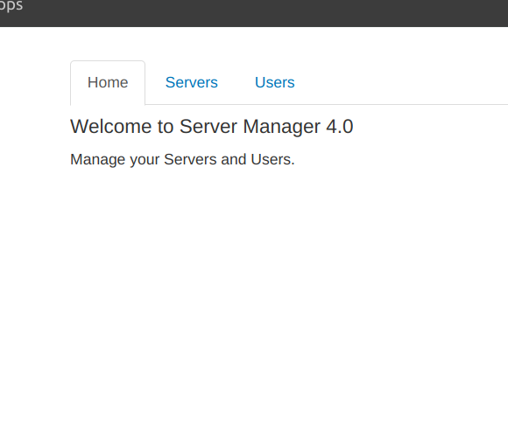

NAVIGATING PROGRAMMATICALLY

when a button is clicked then move to a page.
When we click on a button we need to move to a page | 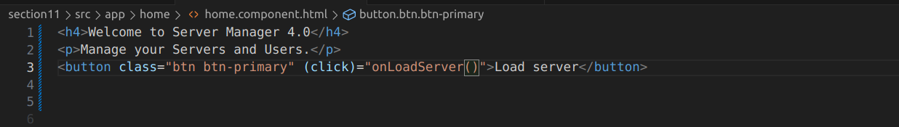
Here we give the navigation path and it works | 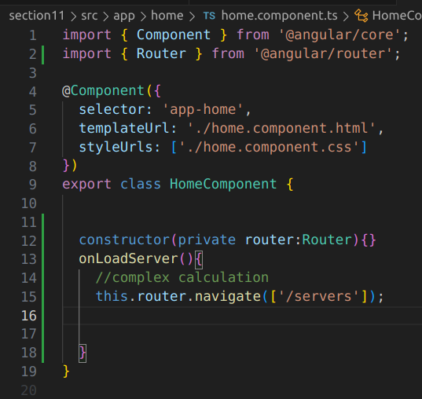
Using Relative Paths in Angular
To pass a relative apth we will be having Activated Route which will give us the currently activated routeand add to it the path. | 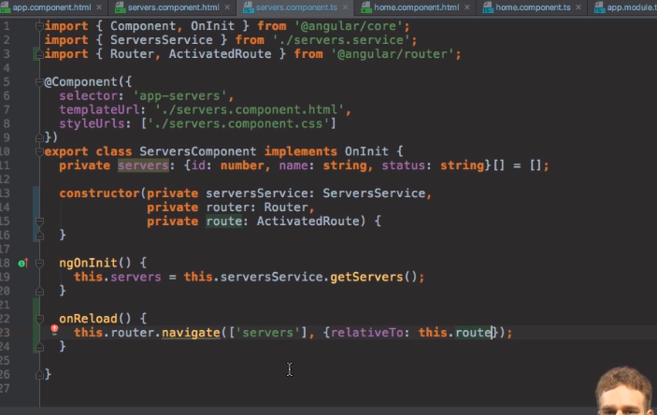
PASSING PARAMETERS TO ROUTES

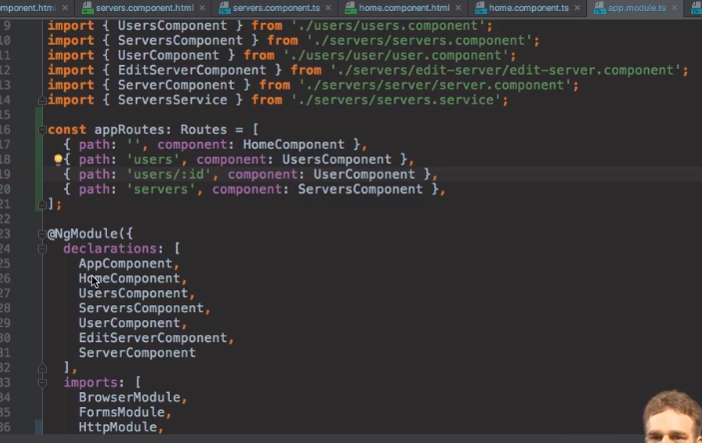
Fetching path params | 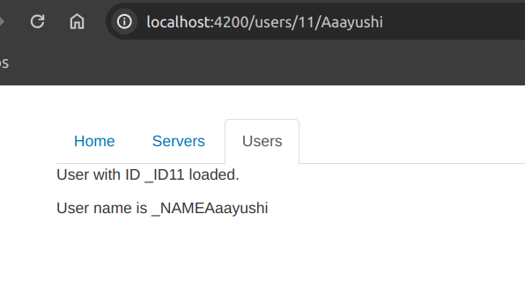
In ordert o fetch path params we need to specify them in the routes | 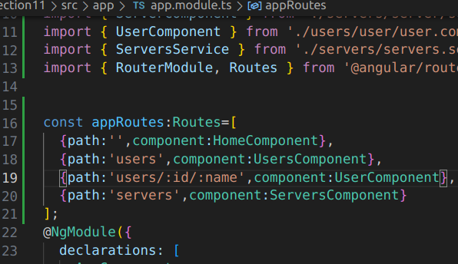
Then in the ts fiel of component we need to take it via the activatedRoute | 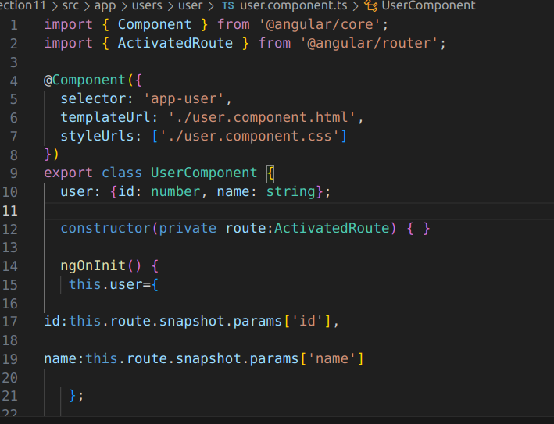
Then we can use html | 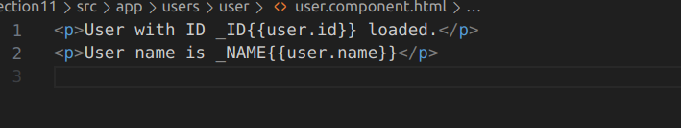
Making router links:  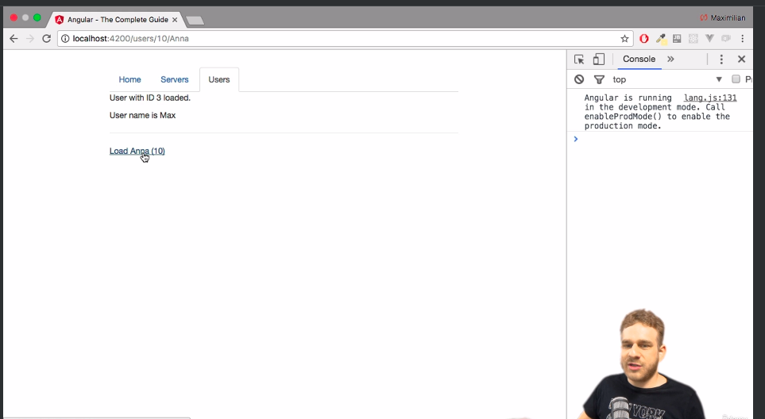  we can make router linkns on our page as shown | 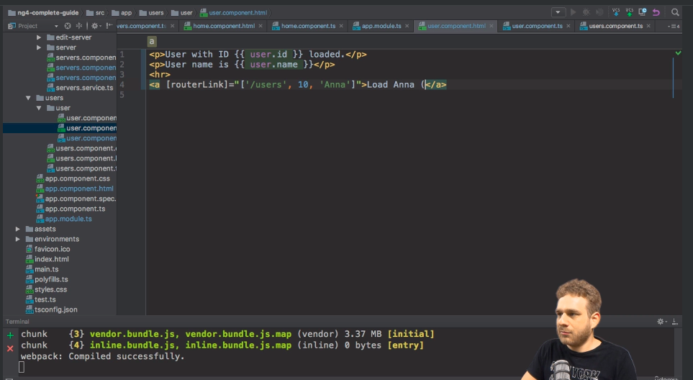
Fetching router parameters reactively.a params will allow us to get data asynchronously without waitng for data to come imdeialty. | 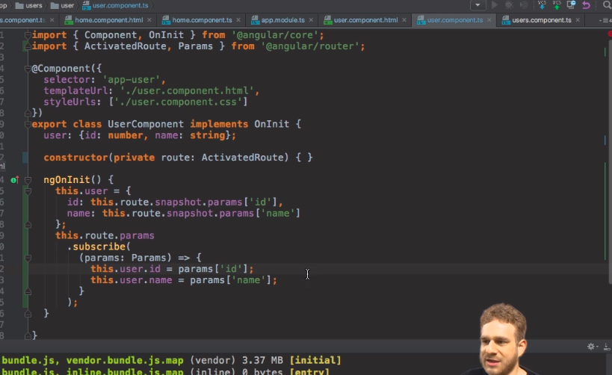  Our user object will be updated hwenever the params change

OBSERVABLE
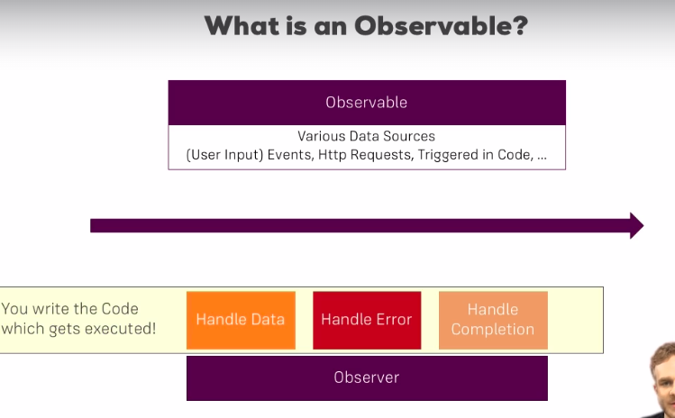
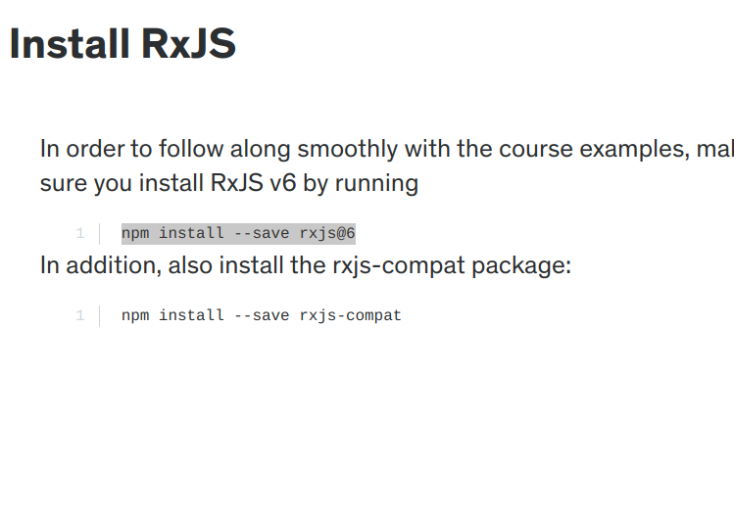
npm install --save rxjs@6
npm install --save rxjs-compat

MAKING A CUSTOM OBSERVABLE

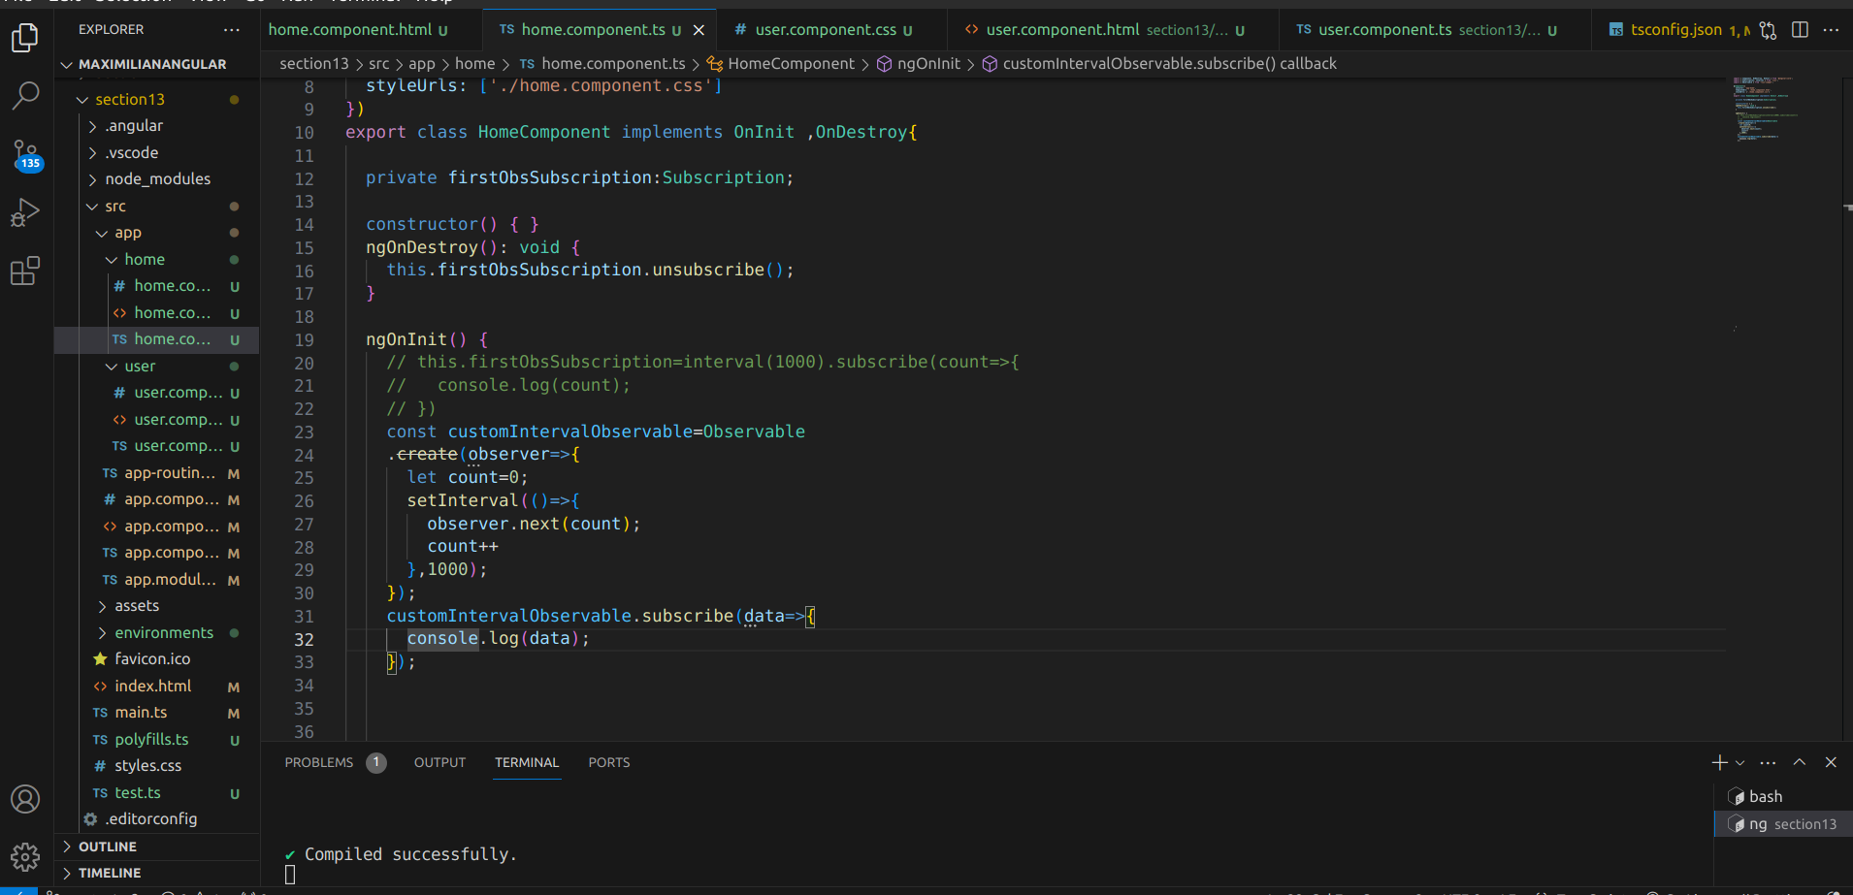
FORMS IN ANGULR
in order to make forms in angular we need to have a forms tag
First we will be making a ts file. | 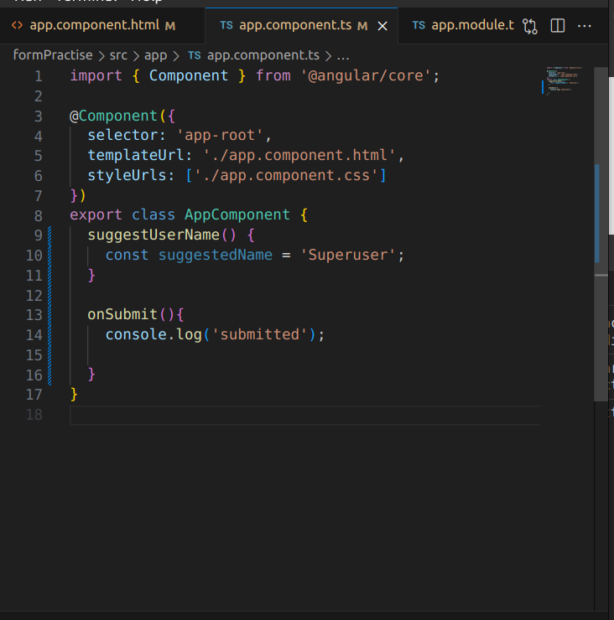
And also we will make a html file having the form submit=”onSubmit”  we will use ngmodel to assign value to properties | 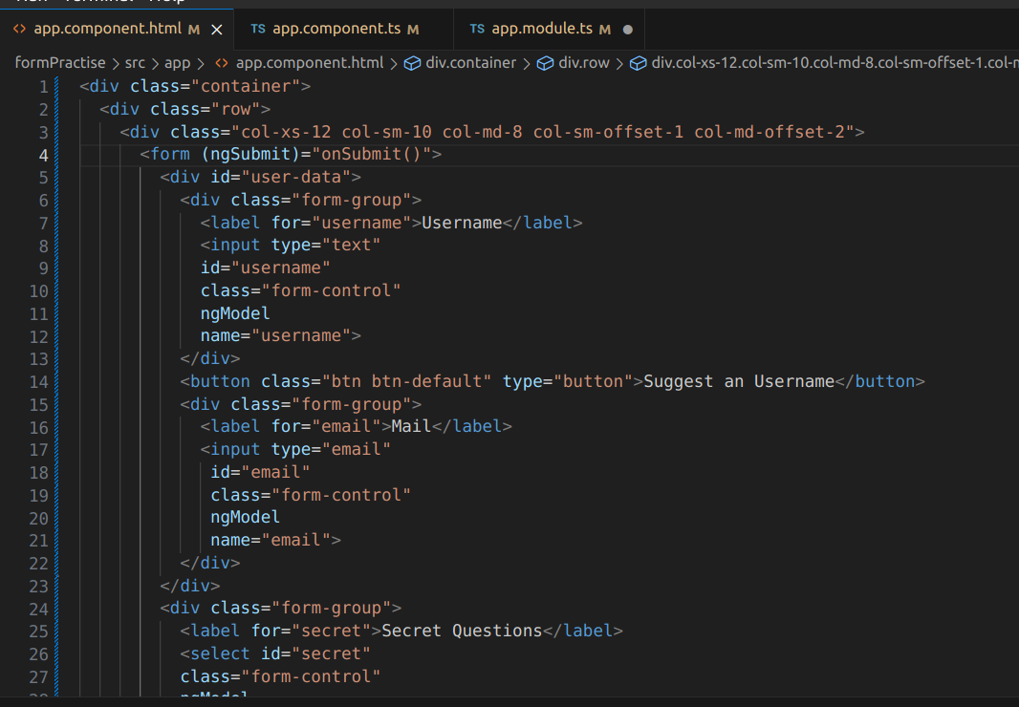
By using we can get access to the form created by angular autnomatically | 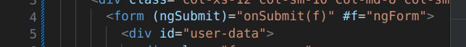
Here we will geta ngform printed in the console if we run below code | 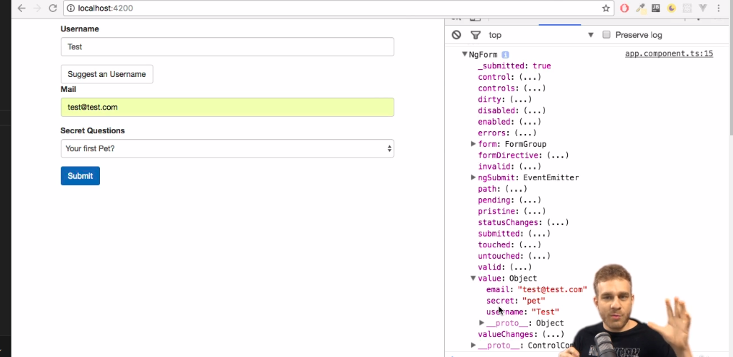
We will be having a ngform type attribute passed to the onsubmit method | 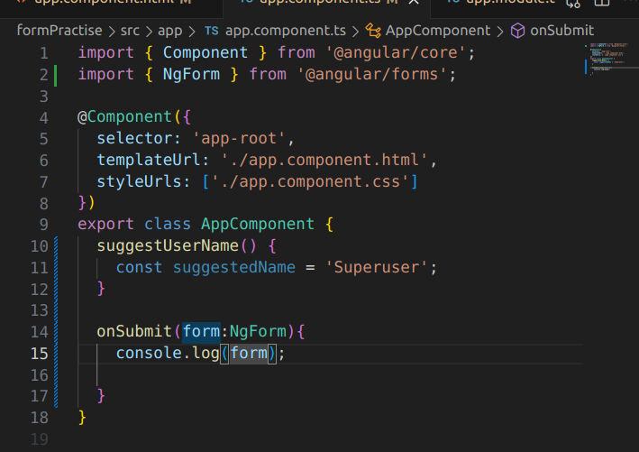
This is th esyntax used in the html file | 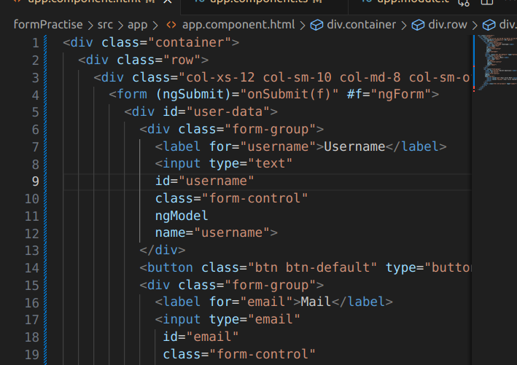
USING @vIEW CHILD TO GET HOLD OF THE FORM
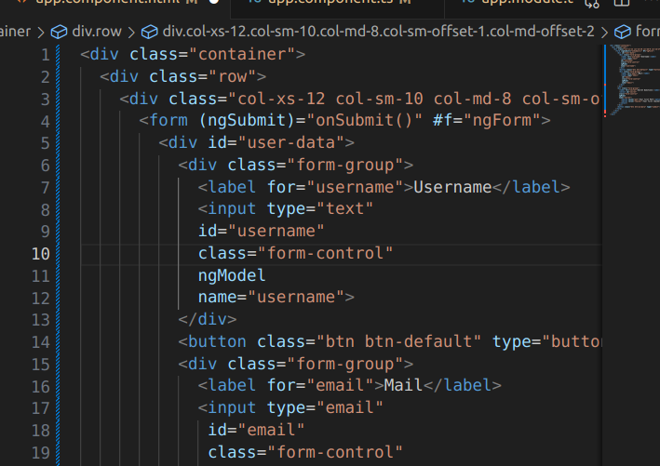
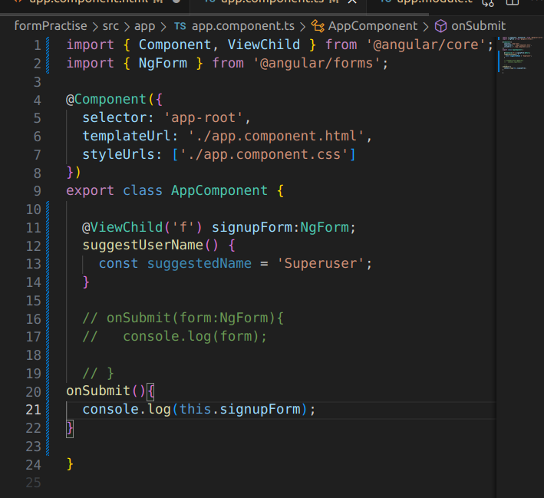
FOMR VALIDATION
we can add form validation by:
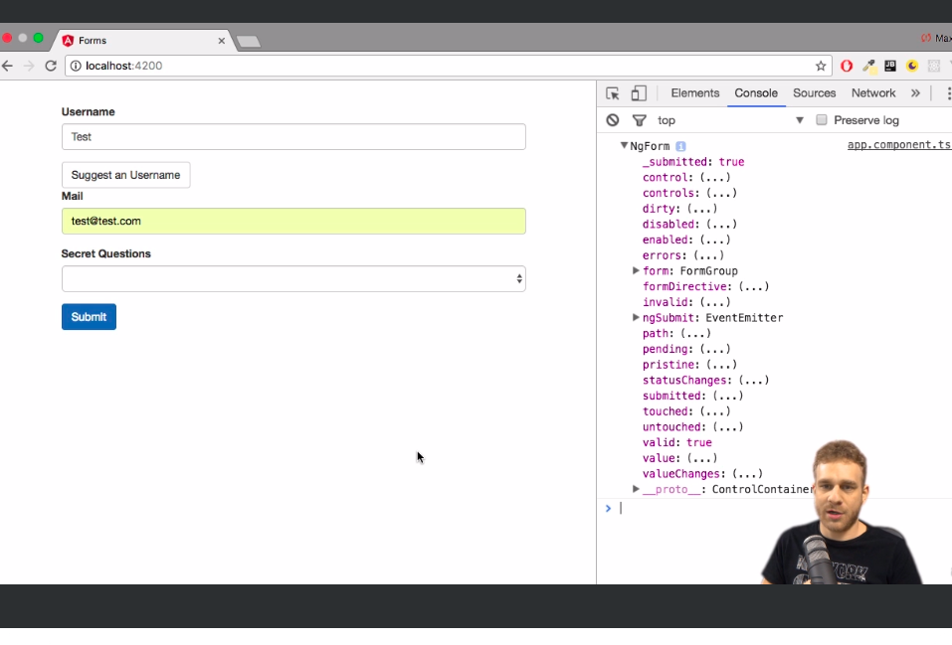 | If we enter valid values then the value of valid in the console will be true else it will be false  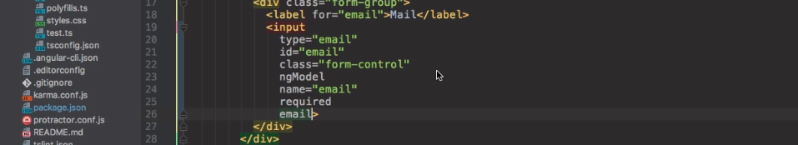
ENABLING AND DISBALING ON BASIS OF FORM DATA
Suppose we have aform and its control is with the #f so now we want to enable submit button only if fomr data is valid so wrtie condition as:(line 43) | 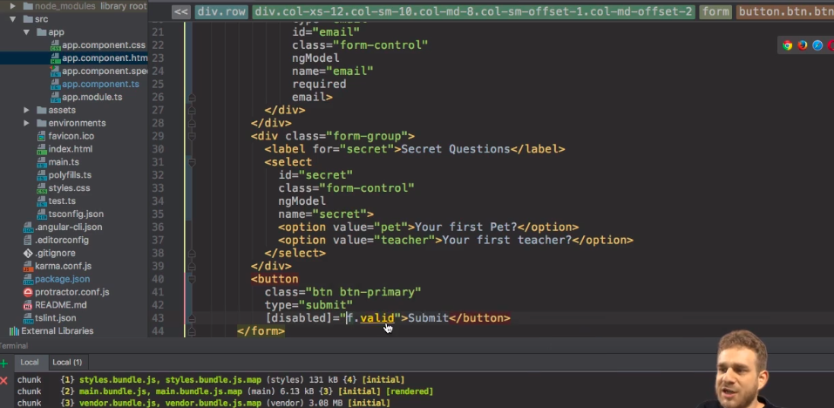
We want to enable a form and mark the invalid fields as red so we will add a property tin th fom input text boxes. | 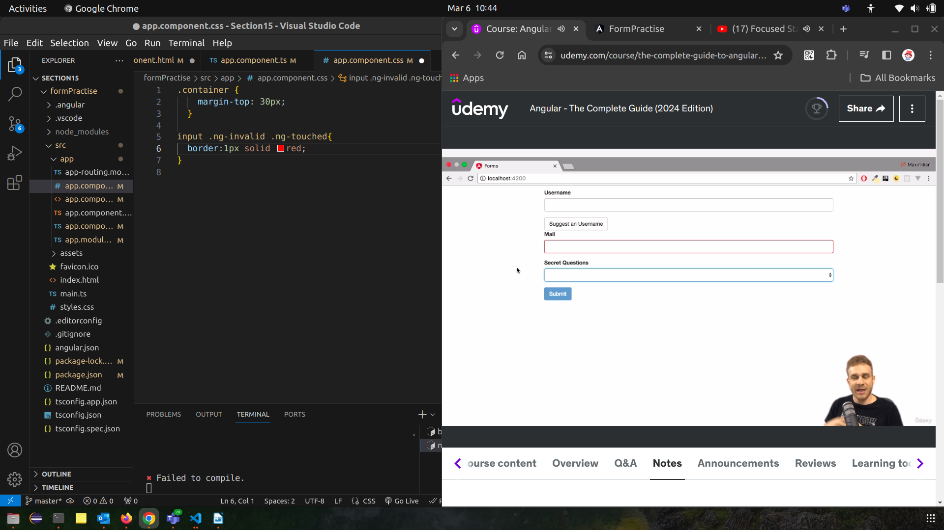
In the form we have field as email whihc needs to be enntered a valid value.so we give it a refernce variable as #email and put a contditon on it that it should be valid an dif it is touched then it should be valid else a span needs to be displayed. | 

